Machacon, Zach Riane BS Computer Engineering 3

Cena, Adrian Miguel September 10, 2023

**Exercise 2**

**EXERCISE 2A**

2A. #1

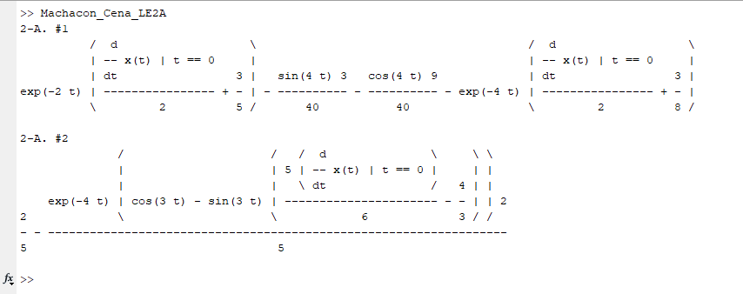

2A. #2

